Friends and Family Test Results – July 2020
The Bovey Tracey and Chudleigh Practice

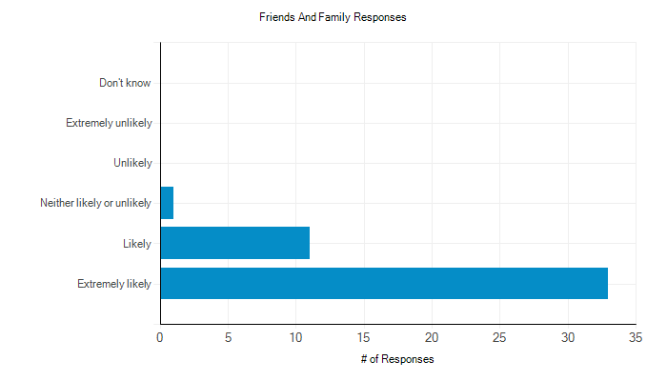

Comments

Response #1:
The GP’s that I have seen are patient and are willing to give you their time. They are there to do their job and do it well.
Response #2:
Due to a number of health issues (both physical and mental) I am a fairly frequent visitor to Tower House ... not only for appointments but also for blood tests, collecting repeat prescriptions etc. I know from all of my past experience that I will be treated with courtesy, kindness and respect at all times, which is very reassuring especially when I am feeling at my most mentally vulnerable. I am always extremely appreciative of every member of your team.
Response #3:
Friendly efficient staff . Clinical staff brilliant, so lucky to have you all. Thank you for all your care .
Response #4:
Helpful and efficient service. Friendly GPs and Staff. Only criticism there could benefit from more than 1 member of staff on Reception.
Response #5:
The consultation with the doctor was good and we discussed the way forward.
Response #6:
Always a friendly face and a pleasant surgery to visit
Response #7:
Would be higher if it were easier to see a GP
Response #8:
One can always get a same-day appointment when it is necessary. I cannot speak too highly of the care we receive from the medical team in-spite of the increased number of many more people coming to live in all the new properties. Thank you very much.
Response #9:
Have seen practice nurse Debbie over the last 6 months, found her friendly helpful and knowledgeable.
Response #10:
I have received the most fantastic care from a really compassionate GP in the last few months, and want to say thank you to the GP. (Also thank you to the friendly helpful reception staff)
Response #11:
I have always found Doctors and Staff very helpful.
Response #12:
I have been registered with GPs in Bovey Tracey all my life and have never had any complaints about the service delivered to me or my family. They have always been responsive and shown respect. My husband and I both went through a particularly difficult patch 2018/19 and the practice were fantastic. They responded what was a very small symptom, immediately referred me to Torbay where cancer was diagnosed and successfully treated. The service by the surgery was exemplary and without their prompt action the outcome may have been very different. Thank you.
Response #13:
We have always had good service and never had cause to complain, brilliant doctors nurses staff, nothing has ever been too much trouble and have been a patient all my life.
Response #14:
Telephone consult, quick and easy.
Response #15:
I was unhappy with my first overall experience with the practice and how some of the reception staff were unhelpful compared to the surgery in Kingskerswell but recent experiences have been good.
Response #16:
Everything very straight forward and easy
Response #17:
Mostly positive experience
Response #18:
Easy online services are very helpful for booking appointments and requesting medicines, surgery is clean, GP's are good.
Response #19:
Friendly and efficient
Response #20:
Very helpful and friendly service by all team at surgery.
Response #21:
It is a nice surgery with pleasant staff.
Response #22:
Always been fabulous whenever I have required treatment
Response #23:
Good friendly service
Response #24:
I have been to the surgery several times in the past year. On each occasion all the staff (receptionists, nurses, assistants, and doctors), were unfailingly polite, helpful and professional, even when things did not go as planned, or when presented with an unexpected situation
Response #25:
Received good service
Response #26:
The contact experiences I have had with GPS, practice nurses and reception staff have been positive, helpful and friendly.
Response #27:
Quick efficient professional treatment administered at all times.
Response #28:
It is an extremely busy surgery, and sometimes not easy to get an appointment without a week or two wait unless an emergency (this was before coronavirus disruption)
Response #29:
Having moved from Plymouth in December 2019, and enrolling with the surgery, I have had very good treatment. The staff are all always polite and friendly.
Response #30:
It did what it said on the tin!
Response #31:
Always get good service from everyone involved.
Response #32:
Always satisfied
Response #33:
Speedy response to requests for a telephone consultation and subsequent follow up.
Response #34:
Professional and considerate
Response #35:
Good GPS AND STAFF
Response #36:
Always treated me well.
Response #37:
Family been with practice
Response #38:
Always helpful
Response #39:
Always helpful
Response #40:
The doctor listened to me and did a number of tests. He was also very considerate.
Response #41:
I have always been able to get a convenient appointment. I have experienced friendly and efficient service from receptionists, nurses and doctors. When I have needed treatment outside the surgery this has been arranged quickly and efficiently.

To ensure that the feedback we receive represents our practice population, please provide the following details.

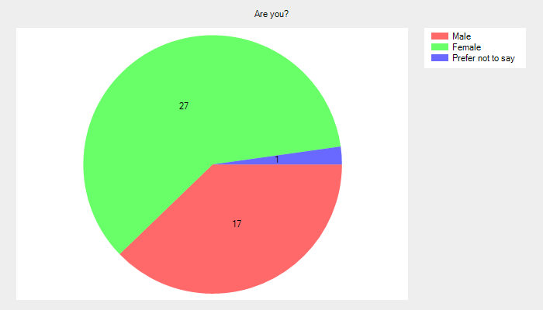
Are you?
- Male - 17 (37.8%).
- Female - 27 (60.0%).
- Prefer not to say - 1 (2.2%).
- No response - 0 (0.0%).

Age Group
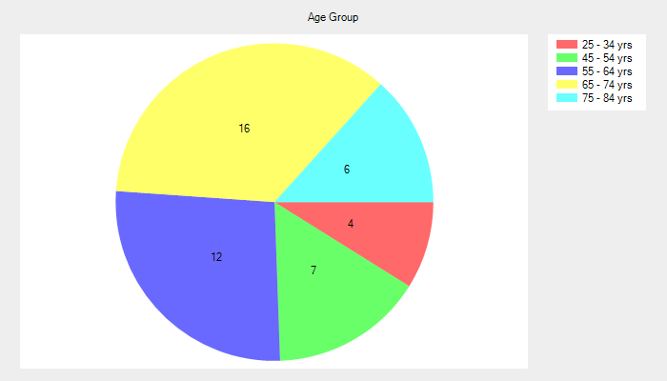
- Under 16 - 0 (0.0%).
- 17 - 24 yrs - 0 (0.0%).
- 25 - 34 yrs - 4 (8.9%).
- 35 - 44 yrs - 0 (0.0%).
- 45 - 54 yrs - 7 (15.6%).
- 55 - 64 yrs - 12 (26.7%).
- 65 - 74 yrs - 16 (35.6%).
- 75 - 84 yrs - 6 (13.3%).
- Over 84 - 0 (0.0%).
- No response - 0 (0.0%).
Ethnic Background
- White : British - 42 (93.3%).
- White : Irish - 1 (2.2%).
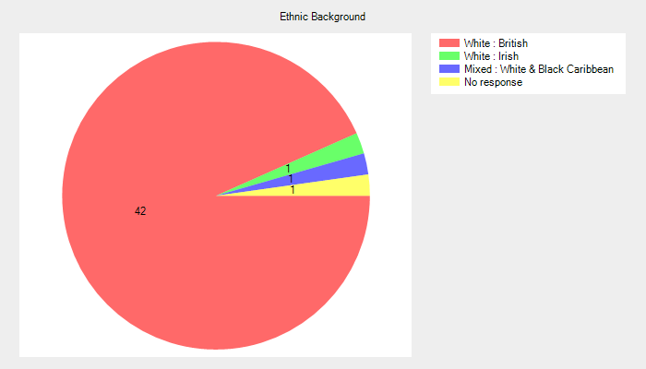
- Mixed : White & Black Caribbean - 1 (2.2%).
- Mixed : White & Black African - 0 (0.0%).
- Mixed : White & Asian - 0 (0.0%).
- Asian or British Asian : Indian - 0 (0.0%).
- Asian or British Asian : Pakistani - 0 (0.0%).
- Asian or British Asian : Bangladeshi - 0 (0.0%).
- Black or Black British : Caribbean - 0 (0.0%).
- Black or Black British : African - 0 (0.0%).
- Other : Chinese - 0 (0.0%).
- Other : Other Ethnic Group - 0 (0.0%).
- No response - 1 (2.2%).

Do you consider you have a long term illness or disability?
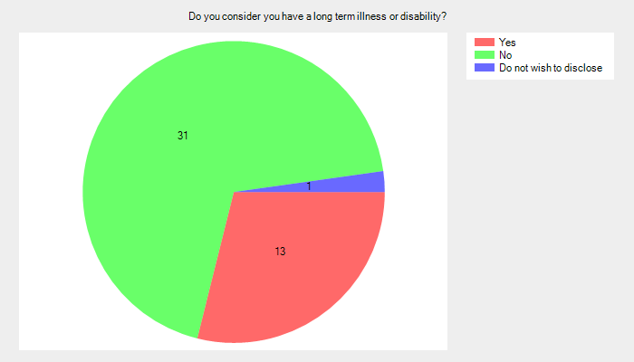
- Yes - 13 (28.9%).
- No - 31 (68.9%).
- Do not wish to disclose - 1 (2.2%).
- No response - 0 (0.0%).

Which surgery do you usually attend?
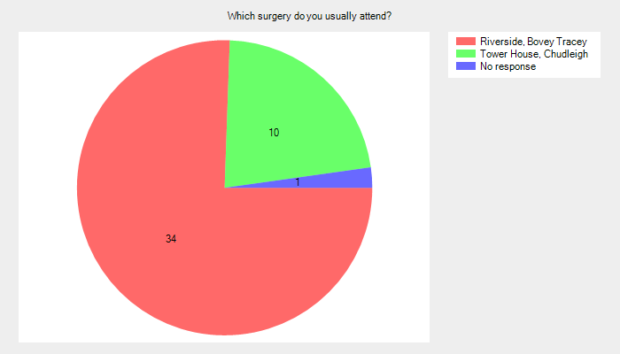
- Riverside, Bovey Tracey - 34 (75.6%).
- Tower House, Chudleigh - 10 (22.2%).
- No response - 1 (2.2%).

