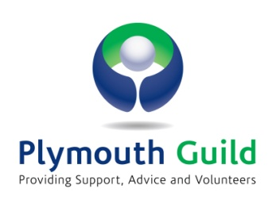
FREE SELF-MANAGEMENT COURSE
FOR PATIENTS WITH LONG TERM CONDITIONS
The Expert Patients Programme is an NHS funded self-referral chronic disease self-management course that provides opportunities to people who live with any long-term physical or low level mental health condition(s) to develop new skills to manage their health better on a day-to-day basis, leading to an improved quality of life.
The course at Guild House, Mannamead, Plymouth, is run over six consecutive weekly sessions of 2½ hours each week and is free. Each week, two volunteer tutors who live with long term conditions themselves, lead 10-14 participants through structured course material such as managing pain, fatigue and depression, relaxation, healthy eating, exercise, breaking the symptom cycle, sleep, falls, medication usage, understanding emotions, working with healthcare professionals and communication. People who have taken part in an EPP course have reported that it has helped them to manage their conditions and treatment more effectively in partnership with healthcare professionals, and they feel more confident and in control of their life.
14 courses are run on different days throughout the year from either
10am-12.30pm or 2pm-4.30pm

at Plymouth Guild, Guild House,
156 Mannamead Road, Plymouth, PL3 5QL.

For more information, registration or referral please contact:

Jan White, Expert Patients Programme Co-ordinator
Tel: 01752 201892 email: jan@plymouthguild.org.uk
http://www.plymouthguild.org.uk/long-term/

