Expert Patients Programme
DO YOU HAVE A LONG-TERM HEALTH CONDITION?

Would you like to:

- Learn new skills to manage your health condition?

- Develop confidence and lead an improved quality of life?

- Meet others and share similar experiences?

- Learn about developing more effective relationships with healthcare professionals?

Join a FREE self-management course
(6 x 2.5 hour weekly sessions) at
Guild House, 156 Mannamead Road, Plymouth, PL3 5QL

For course dates and further information please contact:
Jan White, Expert Patients Programme Co-ordinator
01752 201892
www.plymouthguild.org.uk/long-term/

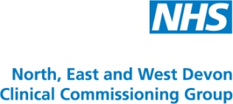

Company Limited by Guarantee Reg.No. 2610208 England Reg. Charity No. 1066776
Company Registered Office: Ernest English House, Buckwell Street, Plymouth, PL1 2DA
Chief Executive: George Plenderleith

